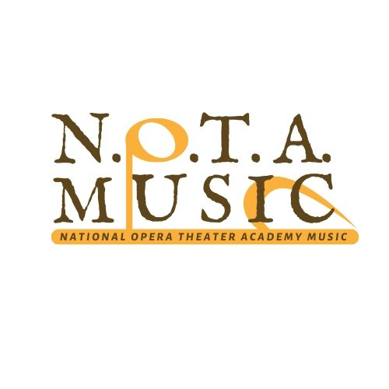
Modulo A

FIRST INTERNAZIONAL COMPOSITION COMPETITION 2021
“Lirica da camera su testi di poeti e scrittori delle case Museo di Romagna”
“ Chamber Composition for Voice and Piano, with poem and texts by poets from Romagna's House Museum”

APPLICATION FORM

FULL NAME (of the composer) FULL NAME (of the parent or the tutor in case of under-18-year-ol persons)

DATE AND PLACE OF BIRTH (of the composer) NAZIONALITY

ADRESS: STREET/SQUARE HOUSE NUMBER

POSTE CODE CITY COUNTRY

EMAIL ADRESS TELEFONE NUMBER

The undersigned declares:
- To partecipate to the First International Composition Competition “Lirica da camera su testi di poeti e scrittori delle case Museo di Romagna” 2021 edition
- To accept the rules of the competition
- All compositions are originals and unpublished

The undersigned gives his consent for the public performance with no remuneration and for the possible audio and video recording and his sharing and storage. The undersigned gives his consent even for an eventual recording and editorial publication without any right or remuneration for the following composition:
- Piece 1……………………………………………………………………………………….
- Piece 2……………………………………………………………………………………….
- Piece 3……………………………………………………………………………………….

The undersigned gives his consent to N.O.T.A MUSIC Association for processing of your personal data as in D. Lgs 196/03- Privacy Code. There must be attached the artistic biografy, a photography of the composer, a copy of the identytity document and the receipt of the registration fee payment.
Date Signature ________________________________________
(signature of the composer or the parent in case of under-18-year-old persons)
To sent by email to notamusic.competition@gmail.com

